# LAPORAN

**Message Queue dengan RabbitMQ**



**O l e h:**

**Erfan Fadhil Juzar**

**2211082006**

# PROGRAM STUDI TEKNOLOGI REKAYASA PERANGKAT LUNAK JURUSAN TEKNOLOGI INFORMASI

**POLITEKNIK NEGERI PADANG**

**2025**

## PERCOBAAN DAN HASIL

Sebelum melakukan percobaan ini ada beberapa hal yang perlu diperhatikan:

* Install RabbitMQ
* Install Golang
  1. Clone project dari GitHub

<https://github.com/kusnadi8605/notification_publisher>

<https://github.com/kusnadi8605/notification_consumer>

* 1. Masuk ke dalam direktori dan install dependensi Go
* go mod init notification_consumer
* go mod tidy
* go mod vendor

* 1. Jalankan kedua aplikasi dan RabbitMQ
     1. Perintah untuk menjalankan RabbitMQ
        + sudo systemctl enable rabbitmq-server
        + sudo systemctl start rabbitmq-server
     2. Perintah untuk menjalankan server cunsomer:
        + go run cmd/consumer/email/main.go
        + go run cmd/consumer/sms/main.go
        + go run cmd/consumer/fcm/main.go

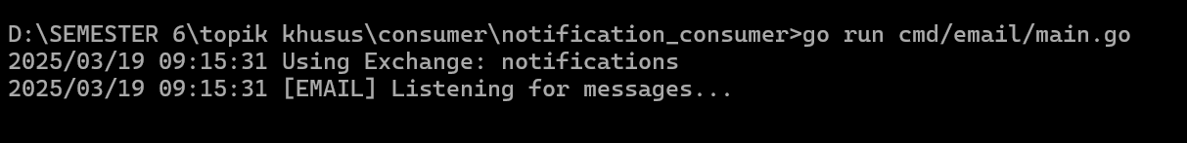

* + 1. Perintah untuk menjalankan server publisher:
       - go run main.go
  1. Menguji Endpoint publish dengan cURL curl -X POST <http://localhost:8080/publish> \

-H "Content-Type: application/json" \

-d '{

"order_id": "12345",

"user_id": "67890",

"content": "New order received",

"timestamp": "2025-03-11T10:00:00Z"

}'

Jika pengujian berhasil maka server email, sms, dan fcm akan menerima notifikasi order

## REFERENSI

<https://github.com/kusnadi8605/notification_publisher>

<https://github.com/kusnadi8605/notification_consumer>